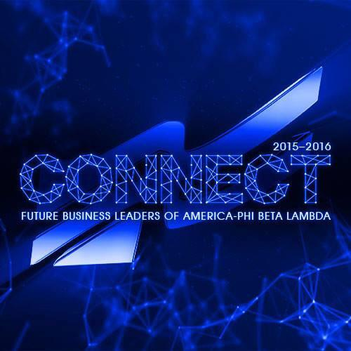

**Future Business Leaders of America—Middle Level**

**What is FBLA?**

FBLA is a national student organization for students in high schools and middle schools. FBLA provides business leaders of tomorrow with the necessary skills to successfully compete in the job market, pursue postsecondary education,

or manage personal skills.

Checklist

* Dues $8 + FLC $15 = $23
* FBLA Policy/Membership Form
* FLC Permission Slip
* Officer Application (optional)

**Activities**

NJHS-FBLA participates in many activities such as:

* Fall Leadership Conference
* Fundraisers for Arkansas Children’s Hospital and March of Dimes
* Spring Leadership Conference (Competitive Events)
* Other activities that meet the goals of FBLA

**Officer Elections**

Officer elections are held at the beginning of each school year. Any student who has paid their dues and turned in forms by September 10 is eligible to run for office. The offices available are:

* President
* Vice President
* Secretary
* Treasurer
* Reporter
* Historian

Officer applications are available from advisers.

**How do I Join?**

**$8.00 DUES + $12.00 FALL CONFERENCE = $20.00 TOTAL**

MCj02511890000[1]Membership in the middle level division is open to all students. Membership Form is attached. Dues are $8 ($4.00 national, $2.00 state, $2.00 local) and are non-refundable. Dues and forms must be turned in at the same time.

Dues and all forms must be turned in by September 10 if you want to run for office or attend the Fall Leadership Conference in October. **THERE IS A SEPARATE REGISTRATION FEE TO ATTEND THE CONFERENCE.**

**Fall Leadership Conference**

Make plans to attend the Fall Leadership Conference on October 6th. The fee is $15 and includes a T-shirt. A permission slip and health form must be turn in with your fee.

|  |  |
| --- | --- |
| **Calendar** | |
| **August** | **January** |
| * Join FBLA | * Complete MAP Awards |
| **September** | **February** |
| * 10th-Membership & Officer App. Deadline | * FBLA Week * Spring Comp. Sign-Up |
| **October** | **March** |
| * 6th-Fall Conference | * Skills Testing |
| **November-December** | **April** |
| * Service Projects | * Online Testing * 27th-Spring Conference |
|  |