PARAGRAPH DIALOG BOX
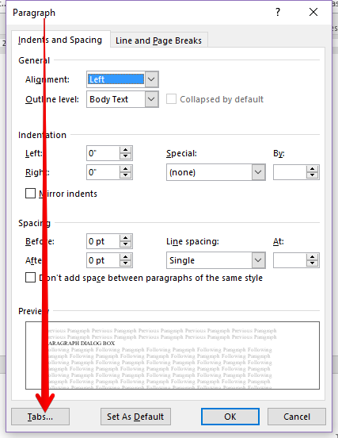
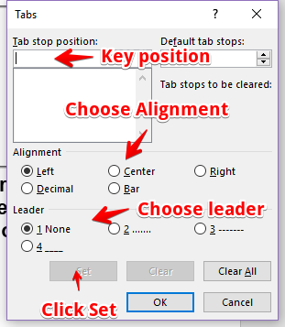

Be sure to choose correct alignment!

Select the words below and set a 4” right tab.
Yellow Purple
Bright Green Blue
Turquoise Silver
Pink Aqua
Red Maroon
Select the words below and set a 3” center tab and a 6.5” right tab.
Color 1 Yellow Purple
Color 2 Bright Green Blue
Color 3 Turquoise Silver
Color 4 Pink Aqua
Color 5 Red Maroon
In the blank line below, set a 6.5” right tab with a #2 dotted leader. Then key this text pressing tab and enter where indicated:

