Use the PARAGRAPH group on the HOME ribbon to format the following text. Point to a button on the ribbon to see what it does.

When formatting a SINGLE paragraph you do NOT have to select the paragraph, just CLICK in it.

LINE SPACING
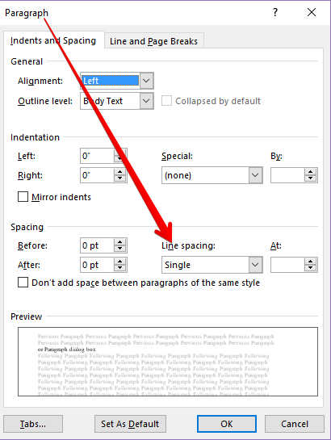
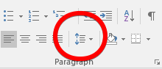

or Paragraph dialog box

Click in each paragraph and change the line spacing of these paragraphs as indicated:
Line Spacing 1.15------Video provides a powerful way to help you prove your point. When you click Online Video, you can paste in the embed code for the video you want to add. You can also type a keyword to search online for the video that best fits your document.

Line Spacing 2.0------To make your document look professionally produced, Word provides header, footer, cover page, and text box designs that complement each other. For example, you can add a matching cover page, header, and sidebar. Click Insert and then choose the elements you want from the different galleries.

Line Spacing 1.5------Themes and styles also help keep your document coordinated. When you click Design and choose a new Theme, the pictures, charts, and SmartArt graphics change to match your new theme. When you apply styles, your headings change to match the new theme.

Line Spacing Double------Save time in Word with new buttons that show up where you need them. To change the way a picture fits in your document, click it and a button for layout options appears next to it. When you work on a table, click where you want to add a row or a column, and then click the plus sign.

Line Spacing 1.15------Reading is easier, too, in the new Reading view. You can collapse parts of the document and focus on the text you want. If you need to stop reading before you reach the end, Word remembers where you left off - even on another device.

After changing line spacing, there may be a blank page 2 or very little text on it. KEEP SCROLLING….there are more exercises to complete.

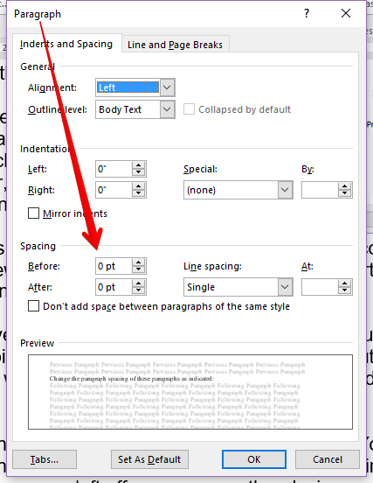
PARAGRAPH SPACING

Change the paragraph spacing of these paragraphs as indicated:
Space Before: 6 pt------Video provides a powerful way to help you prove your point. When you click Online Video, you can paste in the embed code for the video you want to add. You can also type a keyword to search online for the video that best fits your document.
Space Before: 6 pt, Space After: 6 pt------To make your document look professionally produced, Word provides header, footer, cover page, and text box designs that complement each other. For example, you can add a matching cover page, header, and sidebar. Click Insert and then choose the elements you want from the different galleries.
Space After: 12 pt ------Themes and styles also help keep your document coordinated. When you click Design and choose a new Theme, the pictures, charts, and SmartArt graphics change to match your new theme. When you apply styles, your headings change to match the new theme.
Space After: 10 pt ------Save time in Word with new buttons that show up where you need them. To change the way a picture fits in your document, click it and a button for layout options appears next to it. When you work on a table, click where you want to add a row or a column, and then click the plus sign.
Space Before: 10 pt, Space After: 6 pt ------Reading is easier, too, in the new Reading view. You can collapse parts of the document and focus on the text you want. If you need to stop reading before you reach the end, Word remembers where you left off - even on another device.

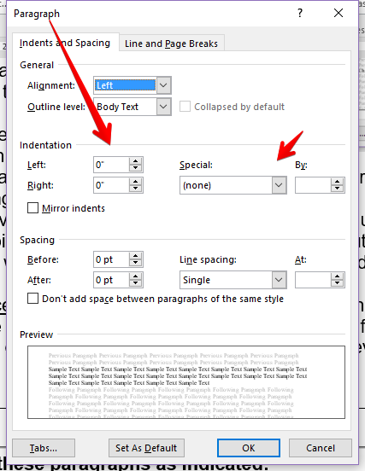
INDENTATION
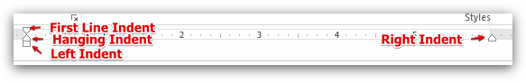

If you do not see the ruler,
go to View, Ruler.

or Paragraph dialog box
Change the indentation of these paragraphs as indicated:
First Line Indent: .5”------Video provides a powerful way to help you prove your point. When you click Online Video, you can paste in the embed code for the video you want to add. You can also type a keyword to search online for the video that best fits your document.
First Line Indent: 0”, Hanging Indent: .5”------To make your document look professionally produced, Word provides header, footer, cover page, and text box designs that complement each other. For example, you can add a matching cover page, header, and sidebar. Click Insert and then choose the elements you want from the different galleries.
First Line Indent: 0”, Left Indent: 1”------Themes and styles also help keep your document coordinated. When you click Design and choose a new Theme, the pictures, charts, and SmartArt graphics change to match your new theme. When you apply styles, your headings change to match the new theme.
First Line Indent: 0”, Right Indent: 1”------Save time in Word with new buttons that show up where you need them. To change the way a picture fits in your document, click it and a button for layout options appears next to it. When you work on a table, click where you want to add a row or a column, and then click the plus sign.
First Line Indent: .25”, Hanging Indent: 1”------Reading is easier, too, in the new Reading view. You can collapse parts of the document and focus on the text you want. If you need to stop reading before you reach the end, Word remembers where you left off - even on another device.
First Line Indent: 0”, Left and Right Indent: 1”------Save time in Word with new buttons that show up where you need them. To change the way a picture fits in your document, click it and a button for layout options appears next to it. When you work on a table, click where you want to add a row or a column, and then click the plus sign.

ALIGNMENT
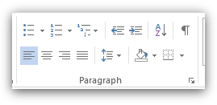
Left
Center
Right
Justify
Align these paragraphs as indicated:
Right Align------Video provides a powerful way to help you prove your point. When you click Online Video, you can paste in the embed code for the video you want to add. You can also type a keyword to search online for the video that best fits your document.

Justify------To make your document look professionally produced, Word provides header, footer, cover page, and text box designs that complement each other. For example, you can add a matching cover page, header, and sidebar. Click Insert and then choose the elements you want from the different galleries.

Center------Themes and styles also help keep your document coordinated. When you click Design and choose a new Theme, the pictures, charts, and SmartArt graphics change to match your new theme. When you apply styles, your headings change to match the new theme.

Left Align------Save time in Word with new buttons that show up where you need them. To change the way a picture fits in your document, click it and a button for layout options appears next to it. When you work on a table, click where you want to add a row or a column, and then click the plus sign.

Justify------Reading is easier, too, in the new Reading view. You can collapse parts of the document and focus on the text you want. If you need to stop reading before you reach the end, Word remembers where you left off - even on another device.

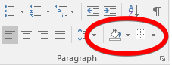
BORDERS AND SHADING
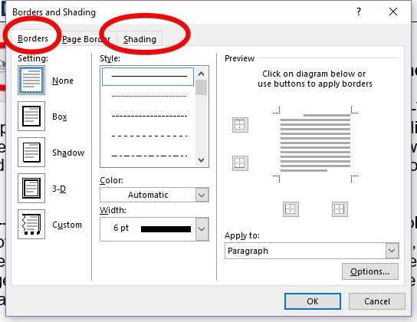
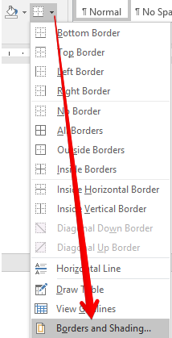
OR

Apply borders and shading as indicated:
Bottom border------Video provides a powerful way to help you prove your point. When you click Online Video, you can paste in the embed code for the video you want to add. You can also type a keyword to search online for the video that best fits your document.

Light Blue Shading------To make your document look professionally produced, Word provides header, footer, cover page, and text box designs that complement each other. For example, you can add a matching cover page, header, and sidebar. Click Insert and then choose the elements you want from the different galleries.

Border-Shadow, 3 pt------Themes and styles also help keep your document coordinated. When you click Design and choose a new Theme, the pictures, charts, and SmartArt graphics change to match your new theme. When you apply styles, your headings change to match the new theme.

Border-Box, Double Line, 1 ½ pt, Purple. Shading-Aqua Accent 5, Pattern 10%------Save time in Word with new buttons that show up where you need them. To change the way a picture fits in your document, click it and a button for layout options appears next to it. When you work on a table, click where you want to add a row or a column, and then click the plus sign.

Border-Box, Dotted, Yellow, 6 pt. Only applied to Top and Bottom. Options: 2 pt Top & Bottom------Reading is easier, too, in the new Reading view. You can collapse parts of the document and focus on the text you want. If you need to stop reading before you reach the end, Word remembers where you left off - even on another device.

INCREASE AND DECREASE INDENT
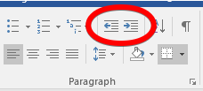

Use the Decrease indent icon to decrease the indentation in this paragraph one time:
I think that I am going to succeed in keyboarding, not only is it learning something new, it is fun learning something new.

Use the Increase indent icon to increase the indentation in this paragraph one time:
I think that I am going to succeed in keyboarding, not only is it learning something new, it is fun learning something new.

BULLETS
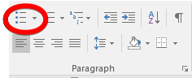
Bullet these words using default bullet:
Keyboarding
Technique
Accuracy
Knowledge
Fun
Bullet these words using a check mark bullet:
Keyboarding
Technique
Accuracy
Knowledge
Fun
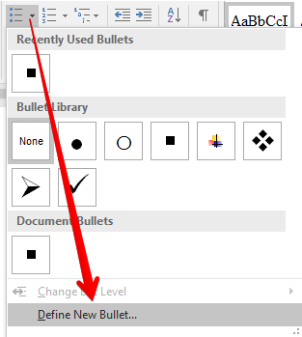
Bullet these words using “Define a New Bullet”, Picture, Arrow from Lesson 04 data files.
Keyboarding
Technique
Accuracy
Knowledge
Fun
Bullet these words using “Define a New Bullet”, Symbol, Wingdings font #74. Change the font color of the bullets to Blue, bold.
Keyboarding
Technique
Accuracy
Knowledge
Fun
Change the bullet alignment position to 0” and the text indent to .5”
(right-click on bullet in list, Adjust List Indents)
- Keyboarding
- Technique
- Accuracy
- Knowledge
- Fun
Increase indent of “Accuracy”, “Speed”, and “MOS Certification”
- Keyboarding
- Accuracy
- Speed
- Computer Apps
- MOS Certification

NUMBERING
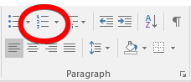
Number these words using the default number style:
Font
Size
Appearance
Alignment
Numbering and Bulleting
Number these words using A. B. C. style:
Font
Size
Appearance
Alignment
Numbering and Bulleting
Number these words using 1) 2) 3) style and change the numbering value to start at 8 (bottom of number drop down menu):
Font
Size
Appearance
Alignment
Numbering and Bulleting

