Use the FONT group on the HOME ribbon to format the following text. Point to a button on the ribbon to see what it does.
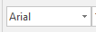
Change the font of these words to their font name:
Arial
Tahoma
Bell MT
Cooper Black
Forte
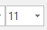
Change the size of these words to:
Size 20
Size 18
Size 22
Size 12
Size 23
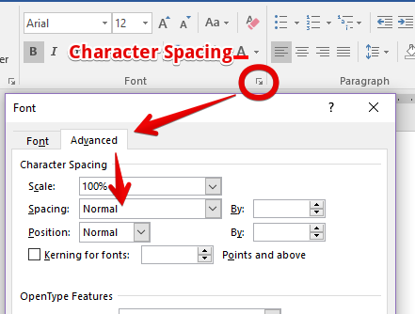
Change the character spacing of these words to:
Expanded 2 pt
Condensed 1 pt
Expanded 3 pt
Condensed .5 pt

Perform the following functions on these words:
Bold
Italicize
Underline
Wave Underline Blue
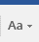
Change the Case of these words:
this is an example of sentence case. see how it capitalizes the first word of the sentence.
CHANGE THIS SENTENCE TO LOWERCASE
Change this sentence to uppercase
Capitalize each word in this sentence with one command
uSE tOGGLE cASE On This Sentence
Open the font dialog box and apply effect as directed to the words or letters after the
Strikethrough Computer Apps
Superscript the ‘2’ 10002
Subscript the ‘2’ H20
Small Caps Nashville Junior High
Apply the appropriate text effect to these words.
Gradient Fill - Purple, Accent 4, Outline – Accent 4
Fill – White, Outline: Aqua – Accent Color 5 Shadow
Fill – Olive Green, Accent Color 3, Sharp Bevel
Color These Words:
Red (standard)
Dark Blue, Text 2
Olive Green, Accent 3, Darker 50%
Yellow (standard)
Aqua, Accent 5, Lighter 60%
Clear the formatting on ONLY the words that are formatted:
We are going to the football game tonight. I hope we win. I love to hear the band play. And our cheerleaders are the best!

