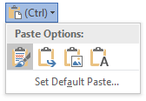
Click Edit Document
Edit in Desktop App

Paste Options Practice

Copy this sentence to the bottom box using the Paste option: Keep Text Only

Copy this sentence to the bottom box using the Paste option: Merge Formatting

Copy this sentence to the bottom box using the Paste option: Keep Source Formatting

Copy this sentence to the bottom box using the Paste option: Keep Text Only

Copy this sentence to the bottom box using the Paste option: Merge Formatting

Copy this sentence to the bottom box using the Paste option: Keep Source Formatting

Paste Options Practice

